Michael Murray – The Caring Cobbler

‘…The cobbler took my hand and place two shillings into it…Patting me on the head…he added some advice: “You don’t need to tell the nuns about your two shillings”. We both smiled and off I went.’

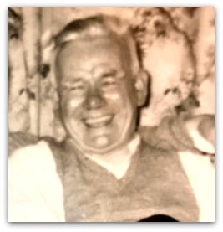
Thanks to an email from Barbara Waller, the big-hearted cobble whose selfless gesture of benevolence towards a young stranger - a precious memory to this day – and one I related as part of my recollections of life in St Mary’s Home (‘Cobblers and Two Shillings’), has been identified as Michael Murray.
“Michael was the cobbler for St Mary's home and worked from a shed - known by the family as 'the hut' and located at the top of Half Moon Lane,” his granddaughter explained.

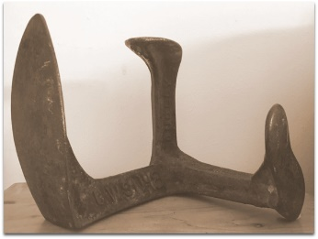
A miner who learned to cobble at Spennymoor Settlement where he attended after an eye problem forced him out of the mines in 1930, Michael lived at 27 Half Moon Lane with his wife Mary, known as Hannah, and their ten children; a fact that only serves to further laud the enormity of his kind act for, as a miner turned cobbler Michael could hardly have been a man of great means and, with a family of ten to provide for, could presumably have ill-afforded to express his good nature in monetary terms –yet that was just what he did!

Extract from spennymoorsettlement.co.uk: ‘A first priority was to give unemployed miners something creative to do with their enforced leisure.’ Symbolically, as it turned out, there was an early class on shoe repairing: ‘The cobblers mended many a worn-out leather sole; the Settlement went on to mend hundreds of worn-out souls.’

I am now in my early seventies and as I reflect, I believe the example set by Michael’s spontaneous, selfless act of human warmth that day significantly impacted on the psyche of the impressionable young lad I was; I have never been able to walk past a person in need or down on their luck I may happen to cross in the street. I always stop and ask them how they are, exchange a few words and part with a couple of coins. As a home boy I had no parents to care for me let alone set any examples and behaviour models I witnessed at St Mary’s were certainly not to be emulated. I am therefore convinced that a great deal of, if not all, the credit for this trait of which I am proud is due to a certain kind-hearted cobbler and a gent: Mr Michael Murray.

“Thank you, Sir, for your kindness to a home boy; if the value of the coin in itself was enormous, your gesture was priceless.”

Brian Roy, 29 April 2018.

Photo of Michael late 1950s early 1960s
Michael’s cobblers last.

